**A**

**PROJECT REPORT ON**

**ATTRIBUTE BASED HYBRID SECURITY FOR DATA IN CLOUD ENVIRONMENT**



**Submitted to:**

**Department of Computer Engineering**

**Cusrow Wadia Institute of Technology**

**PUNE-411001**

**By**

1. **SARAUNSH SHEWALE 154049**
2. **AAKASH SUKRE 154051**
3. **SHRIRAJ CHAVAN 164088**

**A**

**PROJECT REPORT ON**

**ATTRIBUTE BASED HYBRID SECURITY FOR DATA IN CLOUD ENVIRONMENT**



**UNDER THE GUIDANCE OF**

**PROF. MS. JAKOTIYA K.S**

**SUBMITTED BY:**

1. **SARAUNSH SHEWALE 154049**
2. **AAKASH SUKRE 154051**
3. **SHRIRAJ CHAVAN 164088**

**DEPARTMENT OF COMPUTER ENGINEERING**

**CUSROW WADIA INSTITUTE OF**

**TECHNOLOGY,**

**PUNE-411001**

**(2017-2018)**

**CERTIFICATE**

This is to certify that the below mentioned third year Diploma students have carried out the necessary project work on “**Attribute Based Hybrid Security For Data In Cloud Environment**” in the department of Computer Engineering, Cusrow Wadia Institute of Technology, Pune-1. They have completed this project work under my guidance in satisfactory manner in May 2018 of third year Diploma.

1. **SARAUNSH SHEWALE 154049**
2. **AAKASH SUKRE 154051**
3. **SHRIRAJ CHAVAN 164088**

Computer Engineering students have successfully completed project on “**Attribute Based Hybrid Security For Data In Cloud Environment**” towards the fulfillment of their Diploma in Computer Engineering in academic year 2017-2018.

The performance of each of these students during the course was very good.

Date:

Prof. Ms. Jakotiya K. S. Prof Mr. A. A. Jambhale Prof Mr. V. R. Rao

Guide H.O.D. Computer Dept. Principal

**ACKNOWLEDGEMENT**

The success and the final outcome of project required a lot of guidance and assistance from many people and I am extremely fortunate to have got this all along my project work. Whatever I have done is only due to such guidance and assistance.

I respect Prof Mr. A. A. Jambhale sir for giving us opportunity to do the project work and guiding us to complete the project work on time. I am thankful to him for his nice support and guidance in spite of busy schedule.

I owe my profound gratitude to our project guide Prof. Ms. Jakotiya K. S., and all other departmental staff who took keen interest in our project work and guided us all along, till the completion of project work by providing us all necessary information for developing a good system. Also, I would like to extend my sincere regards to all the nonteaching staff of Computer Department for their timely support.

**SARAUNSH SHWALE 154049**

**AAKASH SUKRE 154054**

**SHRIRAJ CHAVAN 164088**

**ABSTRACT**

File sharing is one of the oldest applications of the internet. One way of sharing

files online are, for a user to upload files to a common space on the web and other users can download the files from the common web space.

The objective of this project was to design an online file sharing website where

users can upload files on private space given to them or they can also share with a group of users and other users can download them. To attain this objective an interactive user interface involving features like Upload/Download, creating group, sorting and extensive search capabilities were developed. To make the website more user friendly, users were given two space-constrained visualizations of their file system to view space occupied by the files and folders, and three JavaScript based file management system that works like browsing files on a desktop computer with drag and drop, context menu functionalities etc.

This report discusses the implementation details of the website, and the advantages of having different visualizations of the file system. This report also addresses one frequently asked question regarding file storage; where to store the files, in database as BLOBs or as files in the file system on web server? This report analyzes the time needed to upload, download and search the files stored in both places and discusses the advantages and disadvantages of both techniques in terms of performance, security, integrity, maintenance and code complexity.

TABLE OF CONTENTS

|  |  |  |
| --- | --- | --- |
| **Sr. NO** | Contents | Page no |
| 1. | Introduction |  |
| 2. | Presently Available System |  |
| 3. | Need of such System |  |
| 4. | Detailed problem statement |  |
| 5. | Software and Hardware requirement |  |
|  | 5.1 Software Requirements |  |
|  | 5.2 Hardware Requirements |  |
| 6 | System Design |  |
|  | 6.1 Entity relationship Diagram |  |
|  | 6.2 Data flow diagram |  |
|  | 6.3 use case diagram |  |
|  | 6.4 Class diagram |  |
|  | 6.5 Sequence diagram |  |
|  | 6.7 Activity Diagram |  |
|  | 6.8 component diagram |  |
|  | 6.9 Deployment diagram |  |
| 7. | Application Preview |  |
| 8. | Salient Features |  |
| 9. | Future Prospect |  |
| 10. | Reference |  |

1. **INTRODUCTION**

Online File Sharing is practice of sharing files among different users across the internet. Common forms of file sharing are FTP (File Transfer Protocol) model and P2P (Peer-to-Peer) file sharing network. Another common form of sharing files over the internet is for a user to upload files to a website and allow other users to download them from the website. There are a lot of issues to consider when developing such a website.

Users of an online file sharing website who use features like upload, download, share, search etc. would want a website that is very interactive and fast and not annoying with a lot of post backs and flashing screens. Another issue is the visualization of them

file system where usually users have a limit to upload files.

The normal web-based file folder view would be good, but if there are other types of visualizations it would be great. Another important issue to consider is the location where the website stores the uploaded files. Two places where one can store the uploaded files are Database and Server.

**2. PRESENTLY AVAILABLE SYSTEM**

Currently the Hybrid encryption systemavailable is very complex and hard to maintain. The files encrypted using these algorithms are very complex and hard to understand. Also, these algorithm is not very secured and contains some major vulnerabilities.

This is the main reason many of security to update the algorithm using hybrid encryption.

The normal web-based file folder view would be good, but if there are other types of visualizations it would be great. Another important issue to consider is the location where the website stores the uploaded files. Two places where one can store the uploaded files are Database and Server.

**3. NEED OF SUCH SYSTEM**

Cloud application servers typically are in a remote data center operated by a third party. cloud services infrastructure provider. Cloud-based application tasks may encompass email, file storage and sharing, order entry, inventory management word processing, customer relationship management (CRM), data collection, or financial accounting features.

* One of the major reason why huge number of small scale and large-scale business sectors from all over the world are using cloud today, is because of tremendous effect on **cost saving**. Yes, Cloud computing has made drastic change in the reduction of hardware and software cost and other server resources as well
* We can run all our workload data of applications and processes online over the internet remotely instead of using physical hardware and software
* Day to day issues related to server maintenance or installation of software/ hardware or whether it is renewal of license, all those factors are undertaken via cloud computing service providers
* With the help of cloud, we can access any data, applications whenever

1. **DETAILED PROBLEM SYSTEM**

**WORKING OF SYSTEM: -**

**Problem statement: -**

Online File Sharing is practice of sharing files among different users across the internet. Common forms of file sharing are FTP (File Transfer Protocol) model and P2P (Peer-to-Peer) file sharing network. Another common form of sharing files over the internet is for a user to upload files to a website and allow other users to download them from the website. There are a lot of issues to consider when developing such a website.

Users of an online file sharing website who use features like upload, download, share, search etc. would want a website that is very interactive and fast and not annoying with a lot of post backs and flashing screens. Another issue is the visualization of them

file system where usually users have a limit to upload files.

The normal web based file folder view would be good, but if there are other types of visualizations it would be great. Another important issue to consider is the location where the website stores the uploaded files. Two places where one can store the uploaded files are Database and Server.

**5. SOFTWARE REQUIREMENTS AND HARDWARE REQUIREMENTS**

**5.1. SOFTWARE REQUIREMENTS**

Front-end Software: PHP, JavaScript, Bootstrap, HTML, CSS

Back-end Software: MYSQL, Apache server.

XAMPP with PHP 7.0 Installed

Browsers with JavaScript Enabled.

Cloud Storage

**5.2. HARDWARE REUIREMENTS**

* Processor (at least Pentium 4 700 MHz or more)
* Hard disc (Minimum 20GB)
* RAM (128 MB or more)
* Monitor, Keyboard, Mouse, etc.

.

**6. SYSTEM DESIGN**

The objective of this project was to design an online file sharing website where users can upload files on private space given to them or they can also share with a group of users and other users can download them. To attain this objective an interactive user interface involving features like Upload/Download, creating group, sorting and extensive search capabilities were developed. To make the website more user friendly, users were given two space-constrained visualizations of their file system to view space occupied by the files and folders, and three JavaScript based file management system that works like browsing files on a desktop computer with drag and drop, context menu functionalities etc.

**USER:**

The general user is the user who uses the basic functionality of a system. The general user can perform function like:

1. Upload/Download files
2. Delete files
3. Manage files.

**ADMIN:**

The admin can be a system user and login into the system and can perform functions like:

1. Adding users
2. Deleting users
3. Upload/Download files
4. Creating categories and groups
5. Manage files.

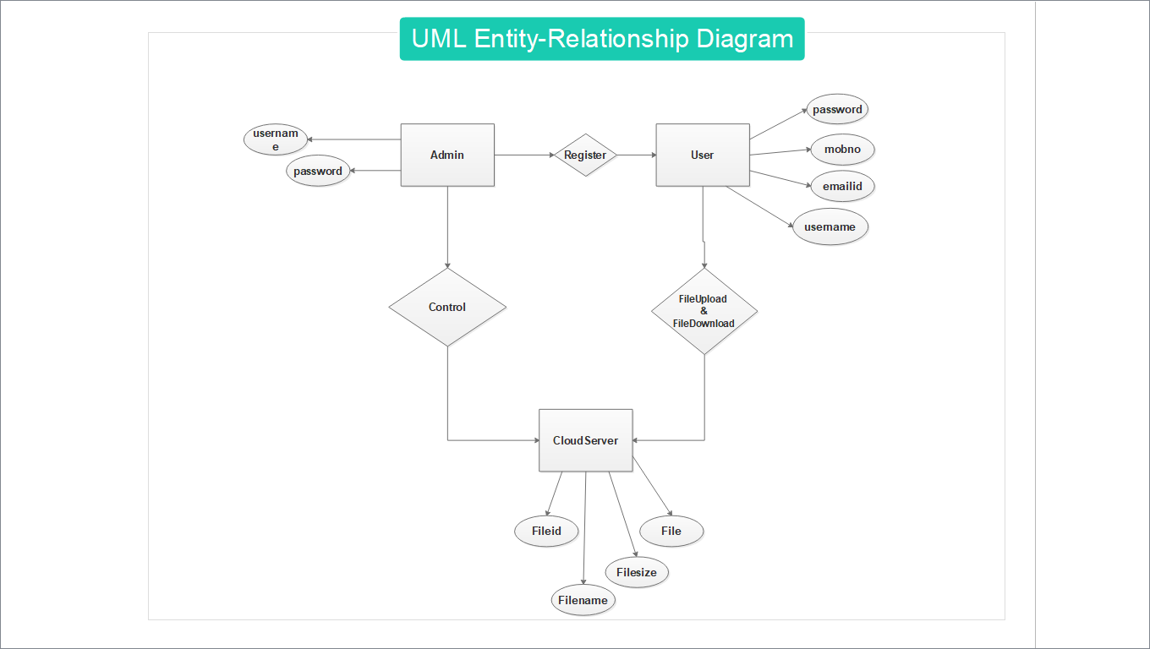**6.1 ENTITY RELATIONSHIP DIAGRAM**

DFD LEVEL 0

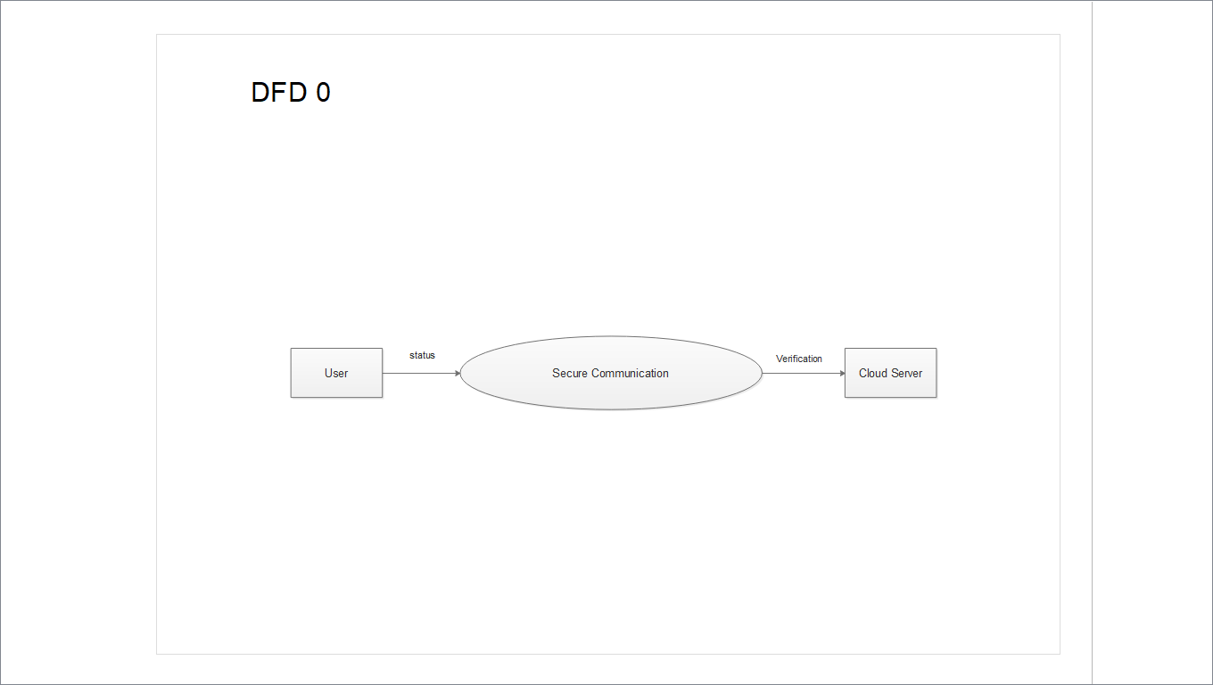

DFD LEVEL 1

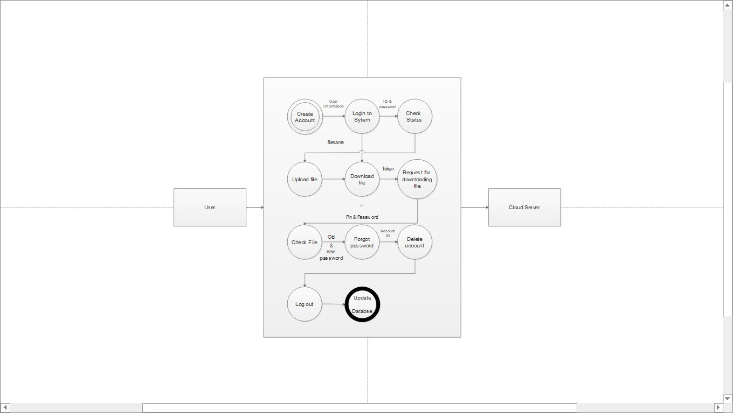

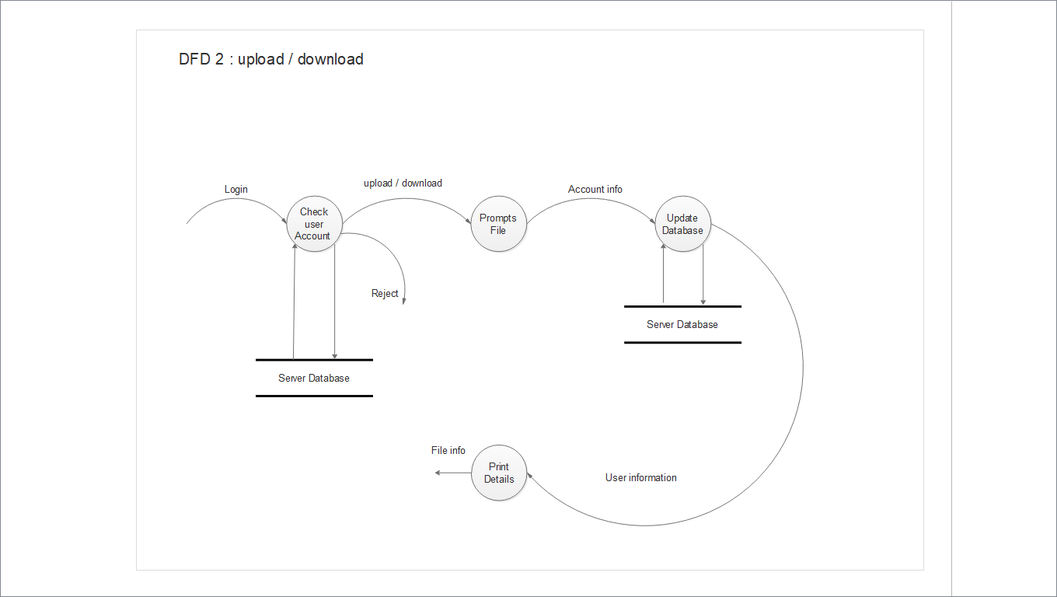DFD LEVEL 2

USE-CASE DIAGRAM

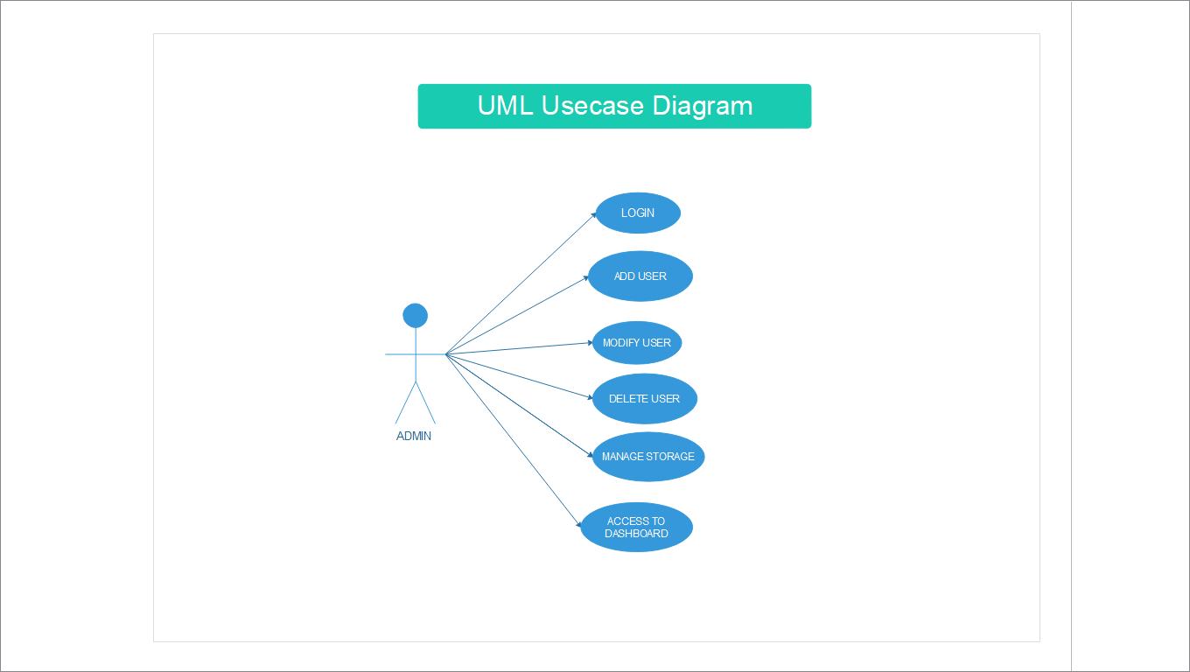

USE-CASE DIAGRAM

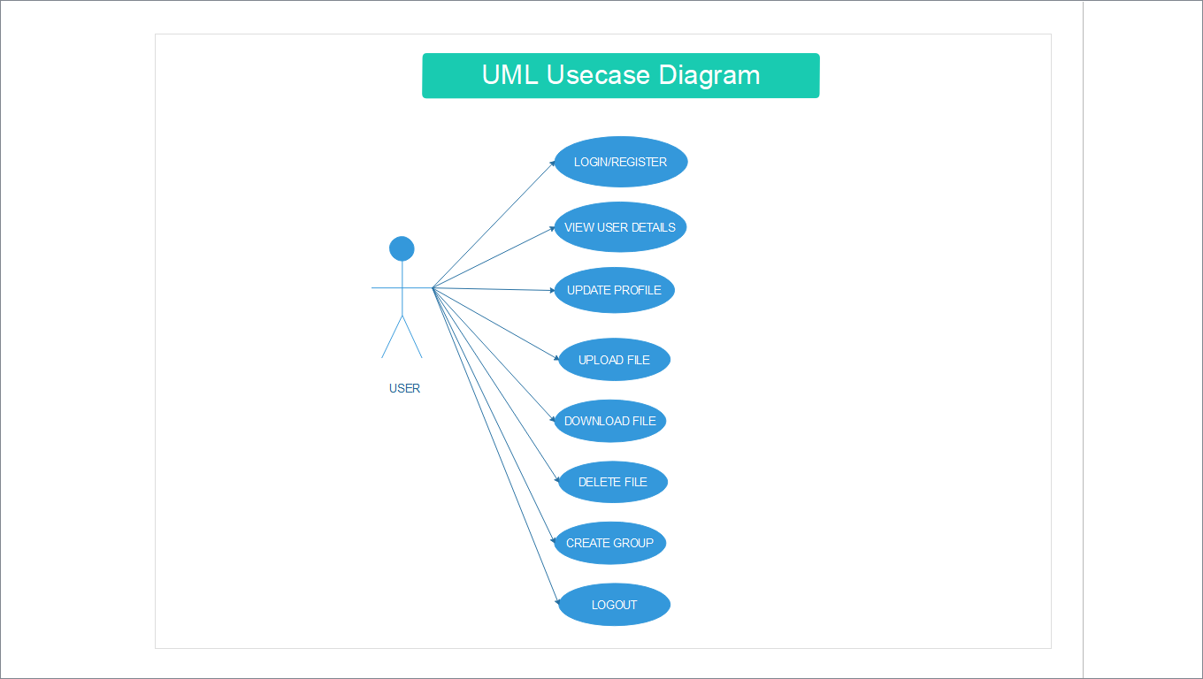

USE-CASE DIAGRAM

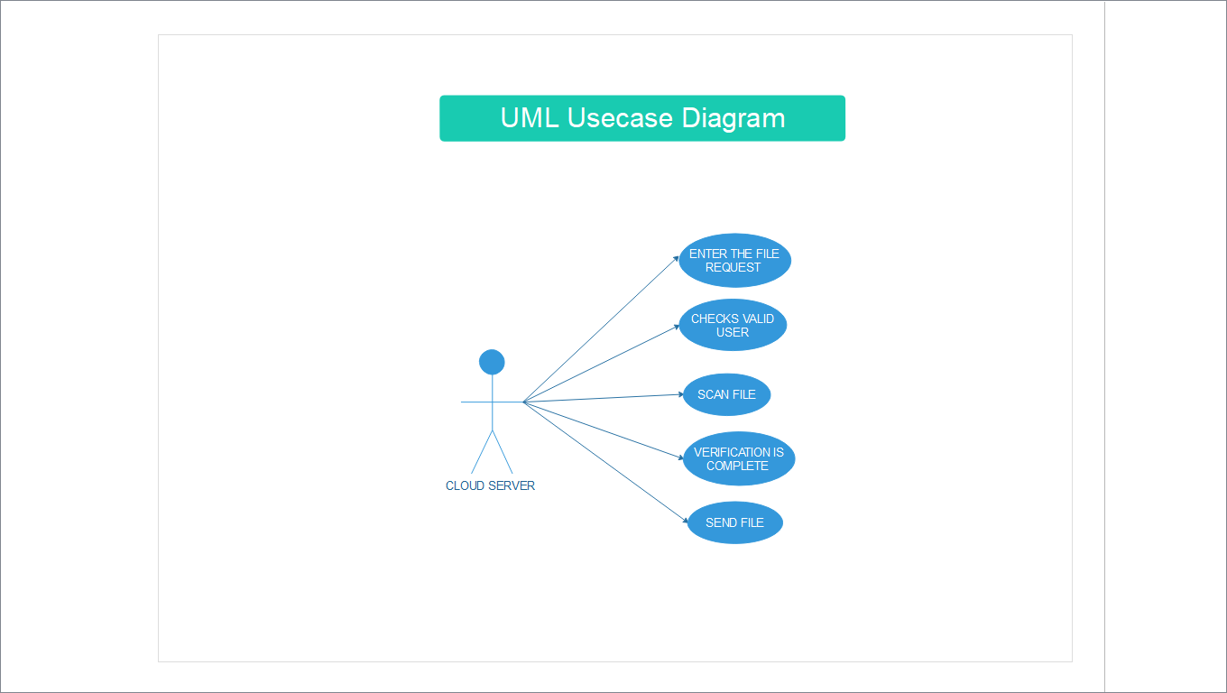

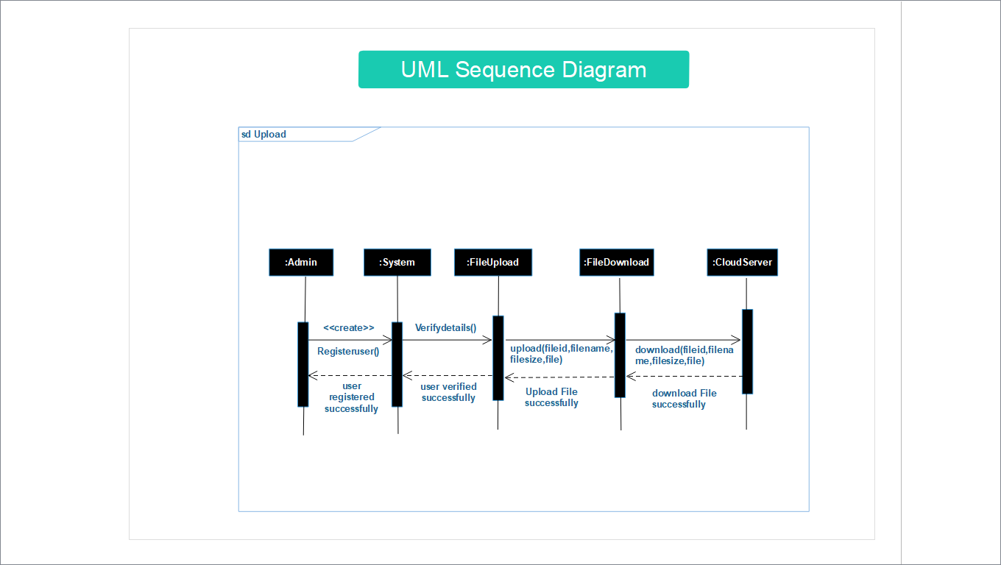SEQUENCE DIAGRAM

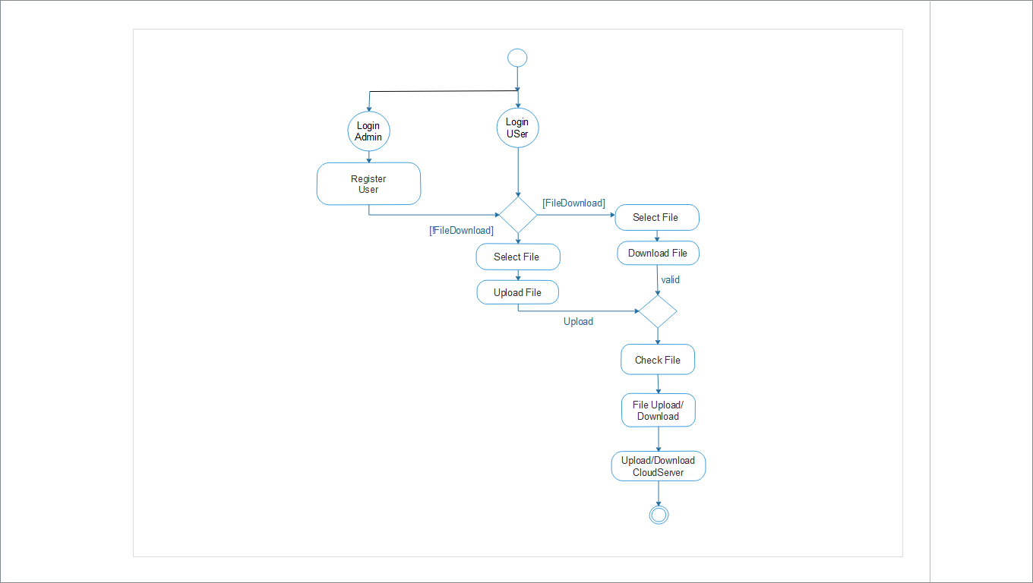ACTIVITY DIAGRAM

COMPONENT DIAGRAM

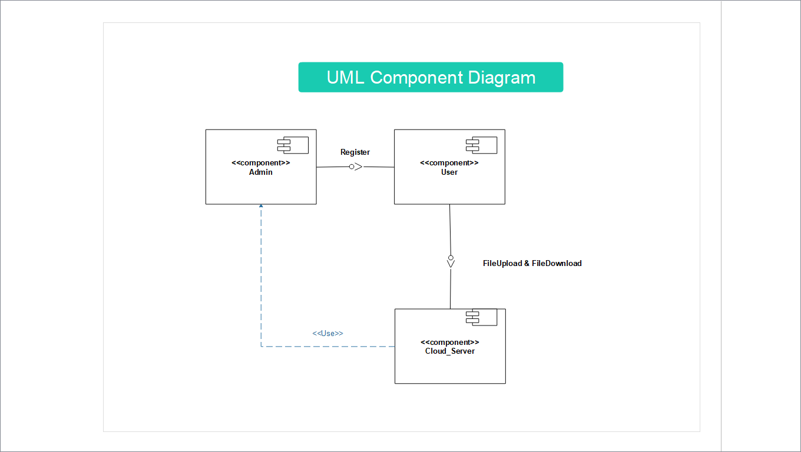

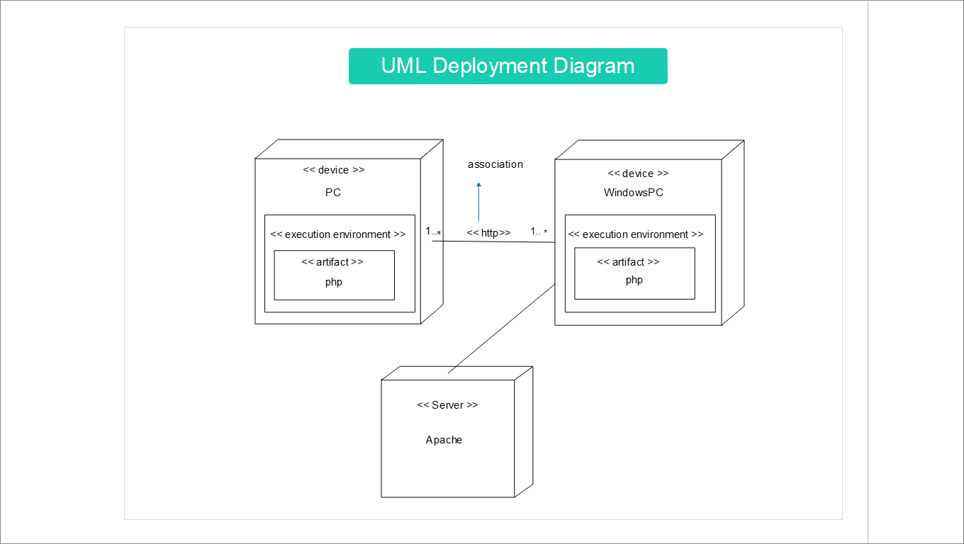DEPLOYMENT DIAGRAM

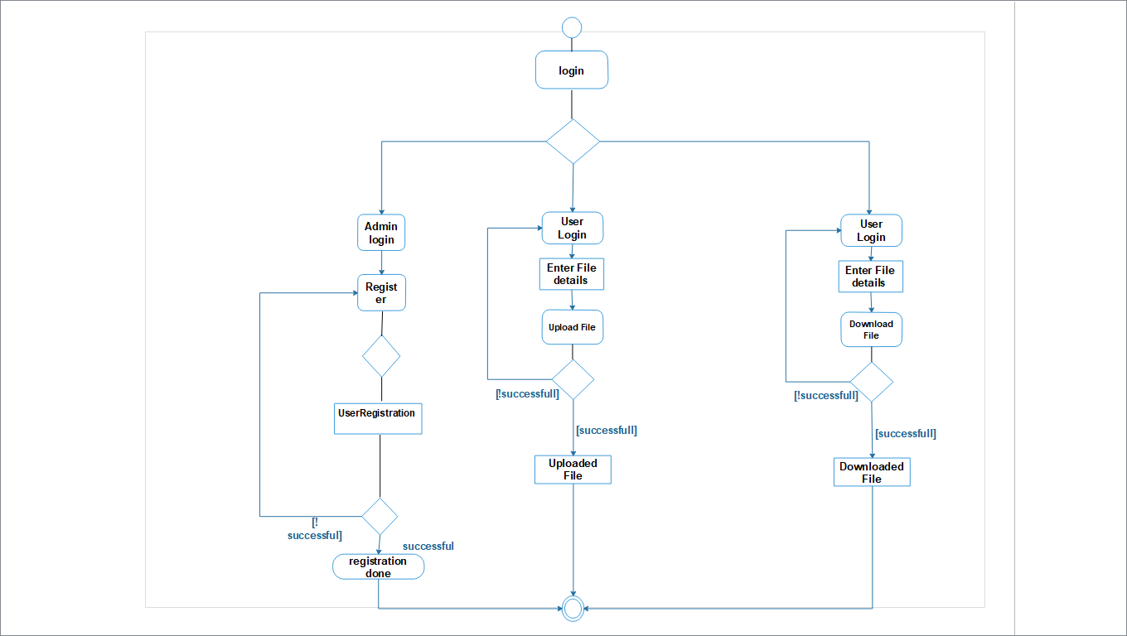STATE MACHINE TEST DIAGRAM

**7. APPLICATION PREVIEW**

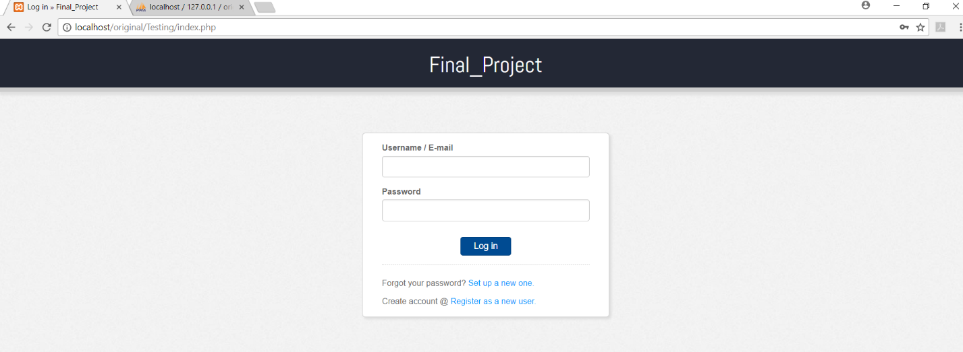1. Login page

**1.1 FORGET PASSWORD**

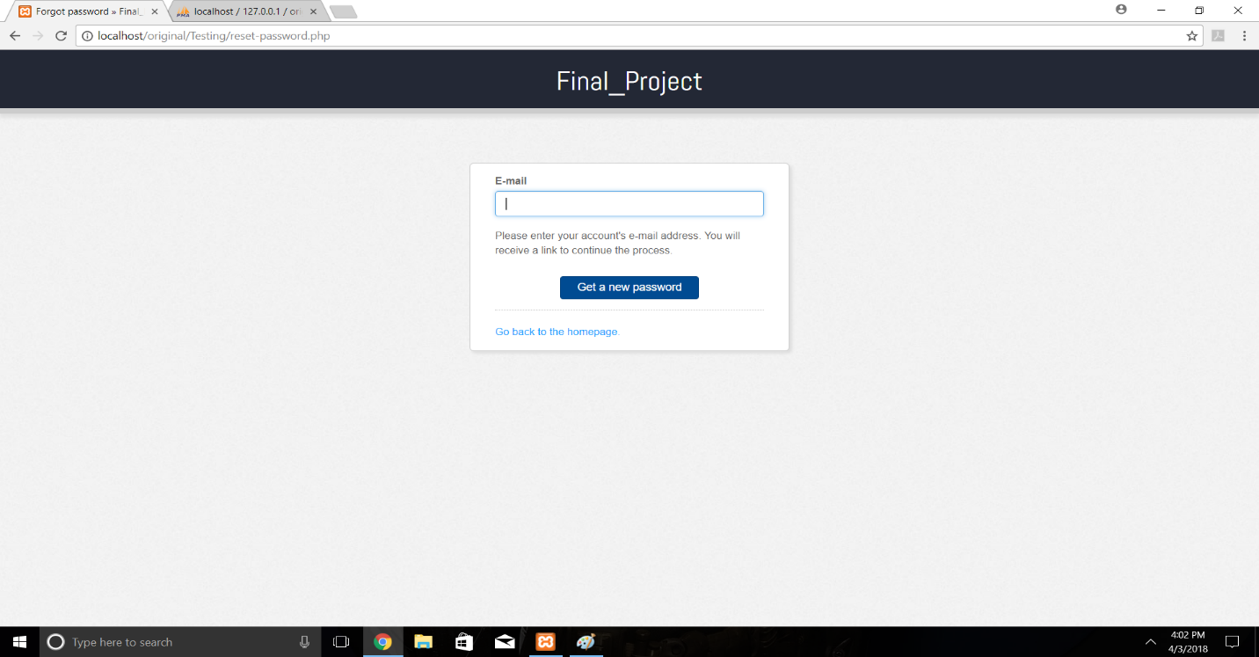

2. REGISTRATION

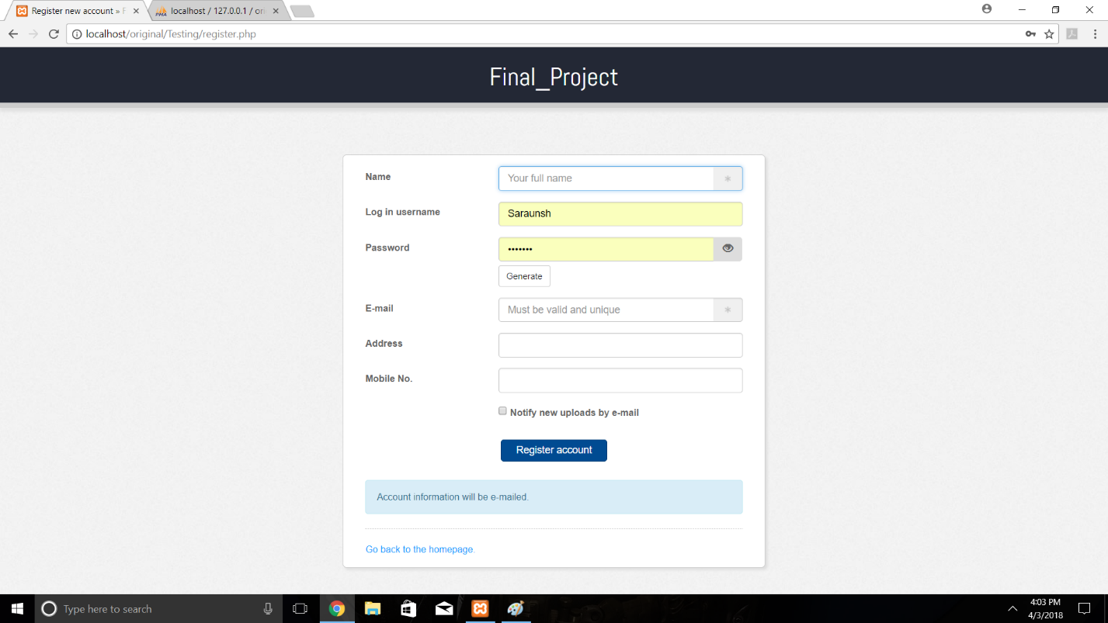

3.SYSTEM USER

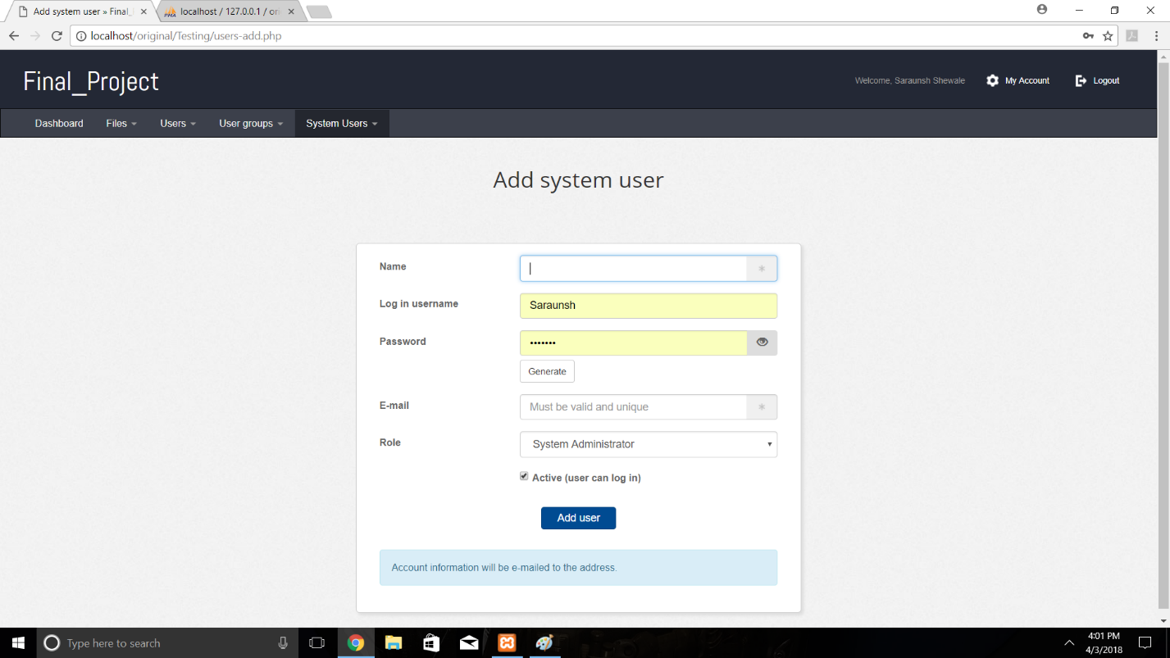

4. ADD USER

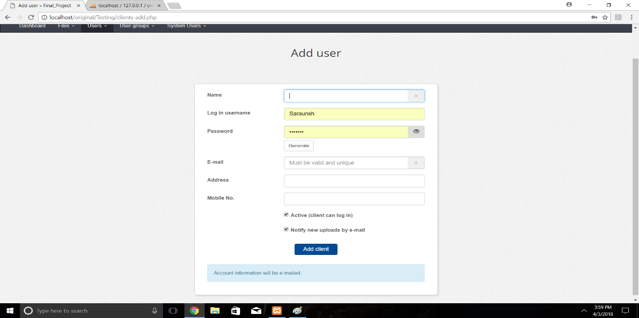

5.USER HOME

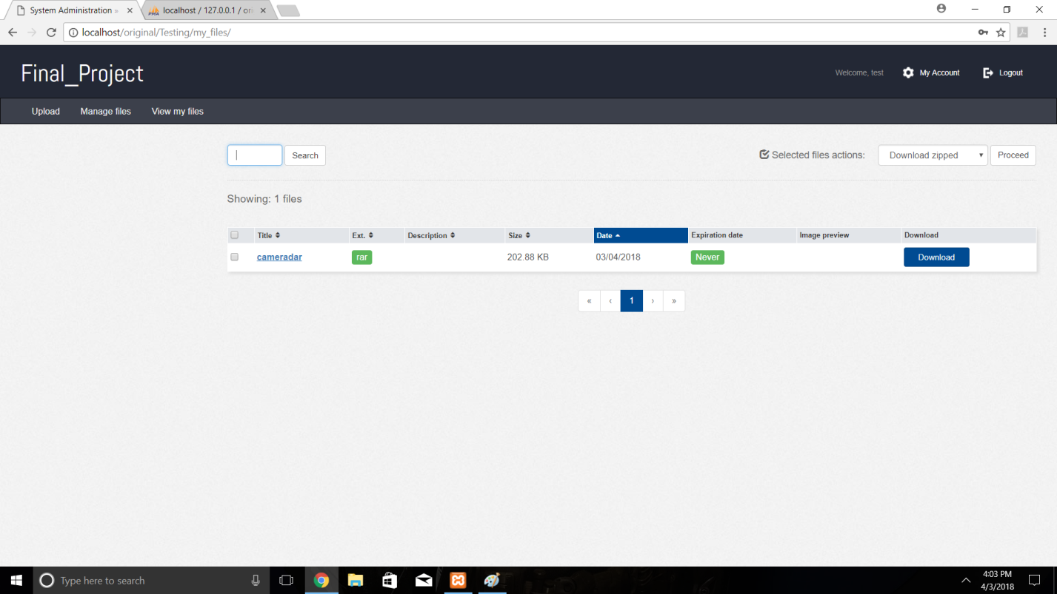

6. DASHBOARD

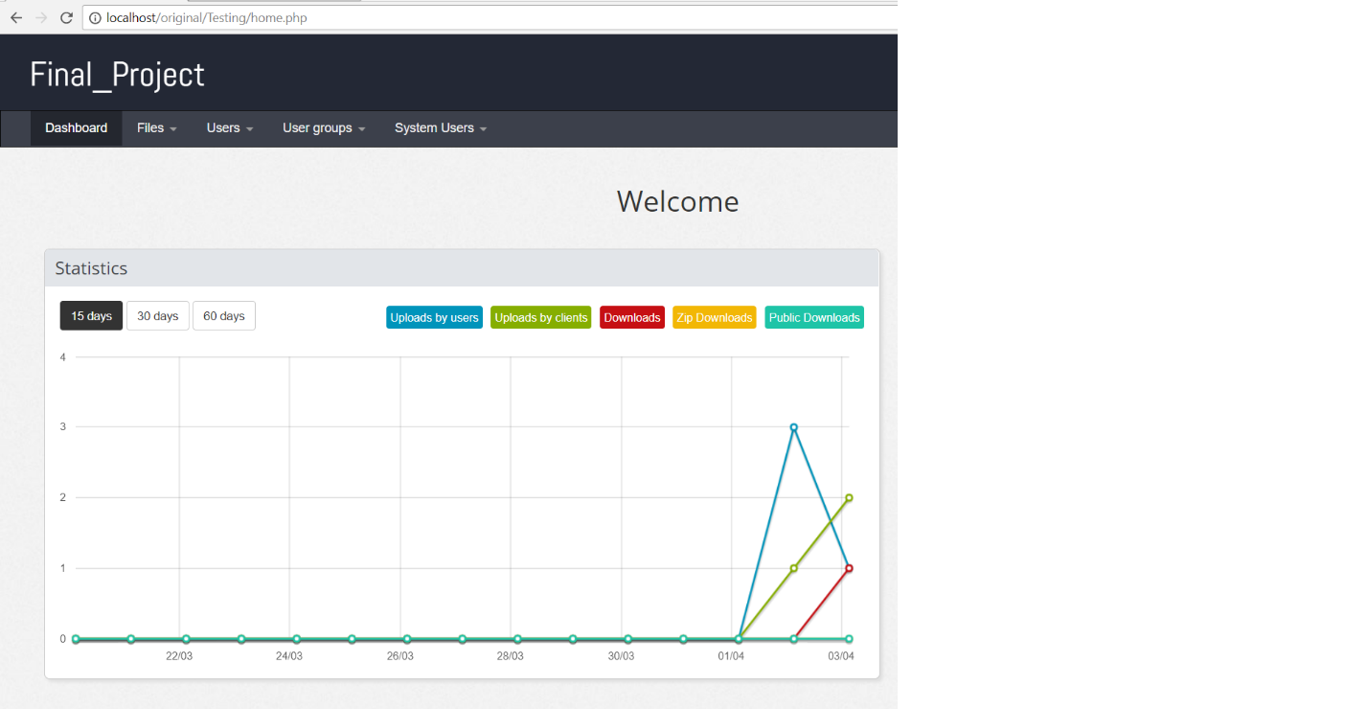

7. MANAGE FILES

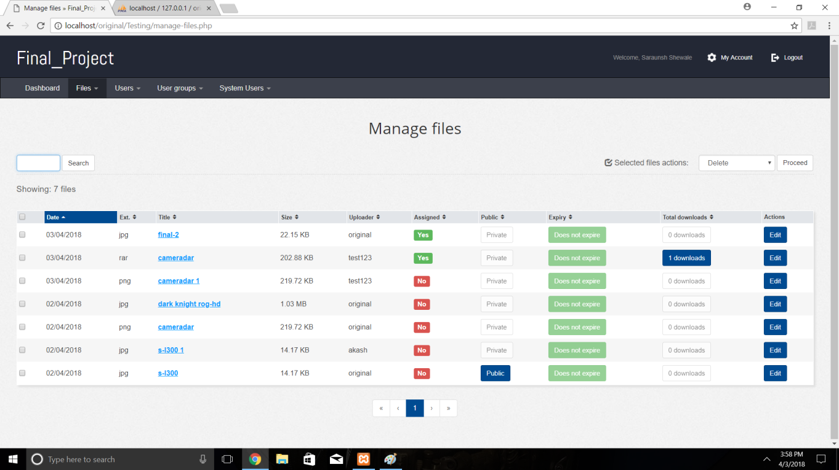

8. ACCOUNT DETAILS

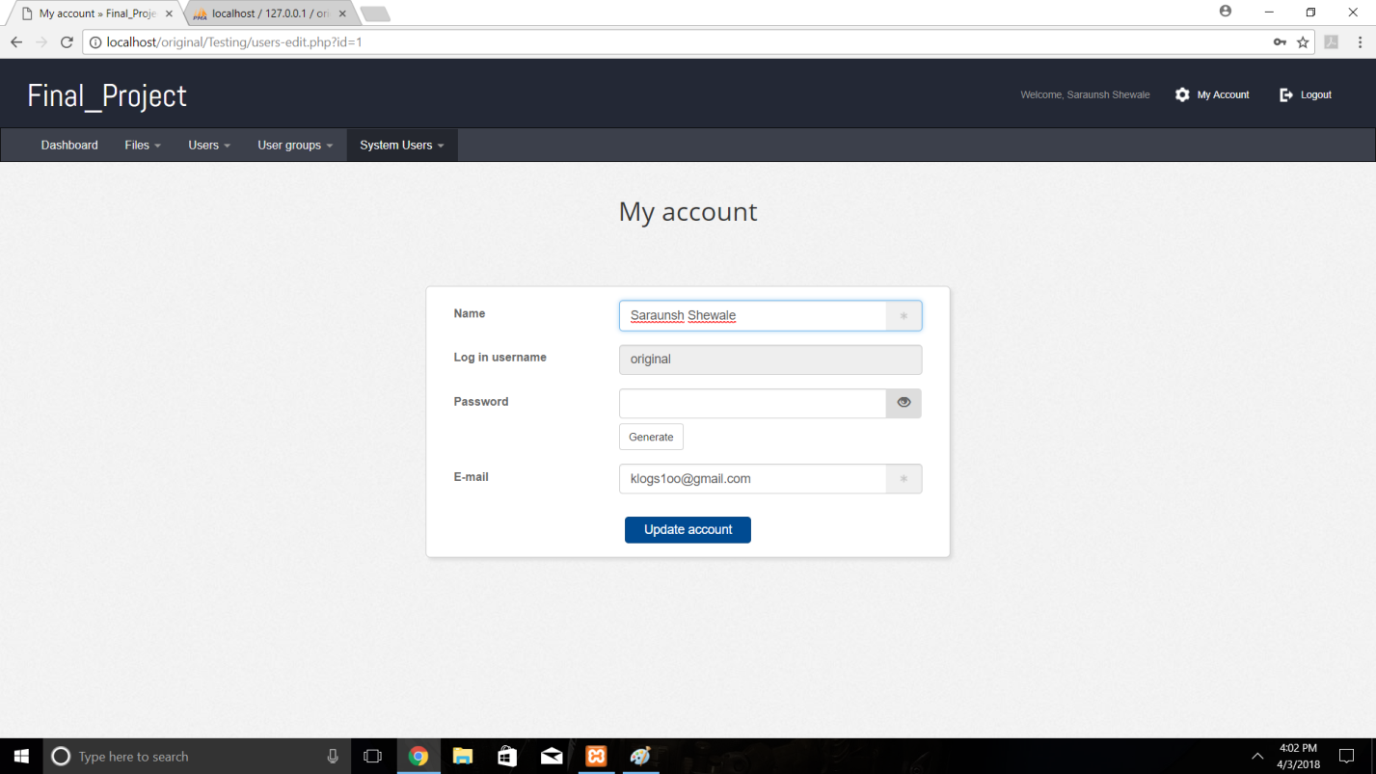

9. UPLOAD FILE

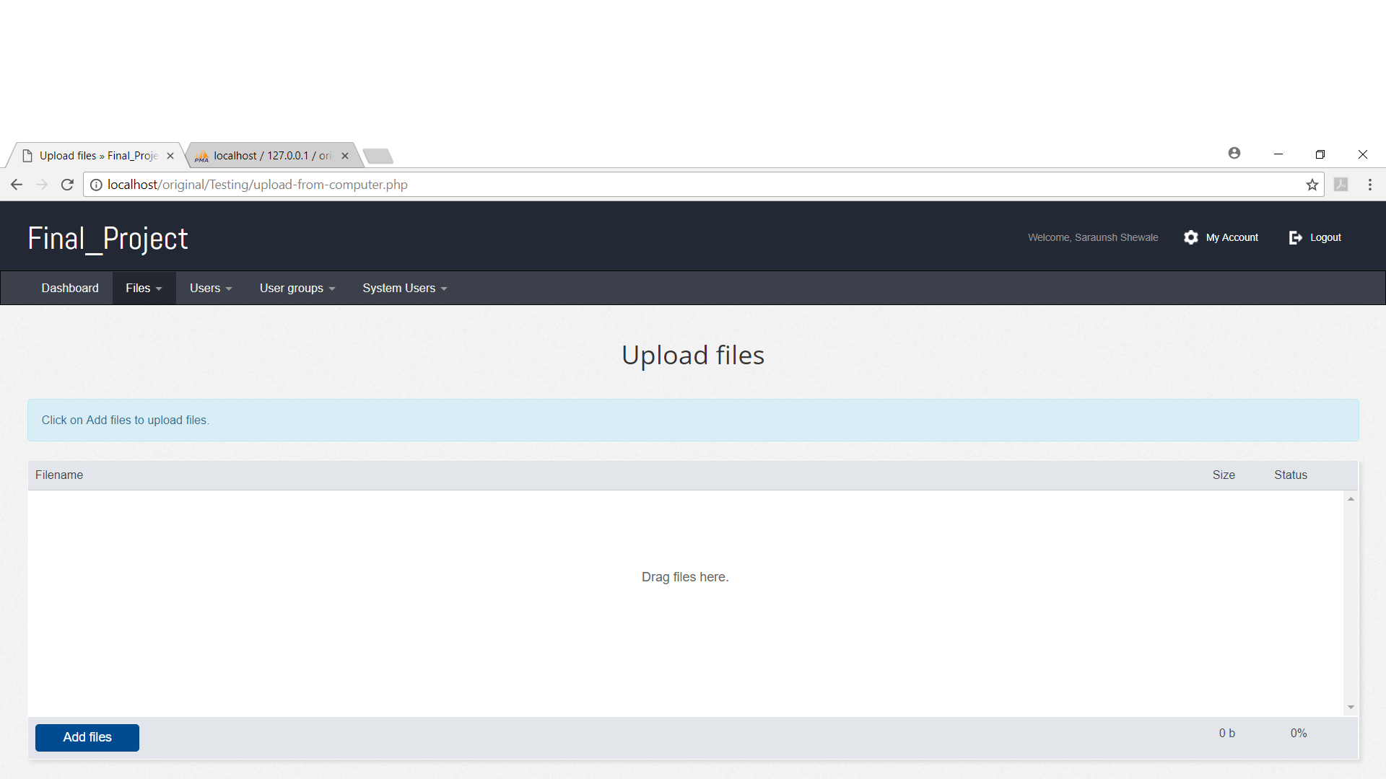

10. ADD USER GROUP

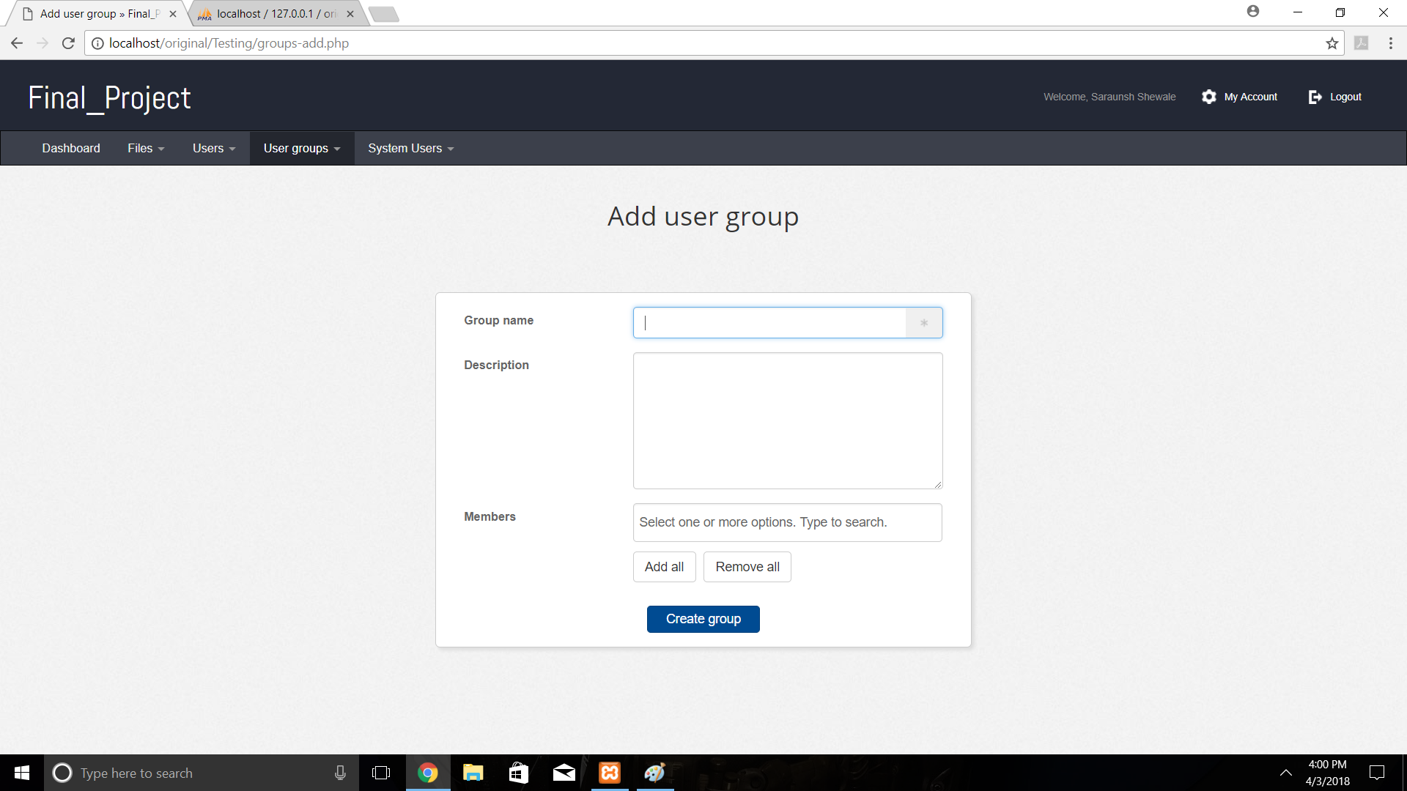

**8. FEATURES**

**System features: -**

* **Secure Files: -**

All of the user’s files are stored on our own VPS server, and when you share your private files, they are kept in your own space.

* **Share within Groups: -**

When you upload your files, you are giving the choice to assign them to a client, or several, or a group that you create specially to work with.

* **Users can Upload as well as Download: -**

Users can upload file to their own private account and also, they can download files of other users account if they have the permission.

* **Detailed Log of Actions: -**

A detailed panel of every activity that happens on the system will be available to administrators.

* **Use of Cryptography: -**

An encryption algorithm is used in this system for providing high level of security.

* Also having unlimited storage space, interactive user interface.

**9. FUTURE PROSPECT**

1. The present system is developed as Web Application. In future we would like to develop it for Portable Devices like Smart Phones and Tablets with even more functionalities.
2. In addition, we would like to Remind Customers to diagnose their Eyes every Month or so using SMS alerts and Emails.
3. We would like to diagnose eyes using Retina Scanning Technologies to read changes in the Bezier curves patterns of the Retina.
4. Currently the chat functionality is limited to Text Chat Consultation but in future we would like to add Video Chat functionality replacing the current system.
5. In addition to just diagnosing the eyes for problems related to daily acquisitions, but in the future we would like to diagnose the eyes for Optical problems with accurate reading from the eyes using Retina Scan Technology.

**10. REFERENCES**

* <https://www.ijedr.org/papers/IJEDR1402124.pdf>
* <https://www.researchgate.net/profile/Ali_Takieldeen2/publication/307545537_Design_and_Implementation_of_Hybrid_Encryption_Algorithm/links/57c7e53a08aec24de042bf4d/Design-and-Implementation-of-Hybrid-Encryption-Algorithm.pdf>
* <https://www.networkcomputing.com/data-centers/7-ways-secure-cloud-storage/866645128>